Ideation Phase

Define the Problem Statements

|  |  |
| --- | --- |
| Date | 22 June 2025 |
| Team ID | LTVIP2025TMID50687 |
| Project Name | visualizing housing market trends: an analysis of sale prices and features using tableau |
| Maximum Marks | 2 Marks |

Customer Problem Statement Template

A well-articulated customer problem statement allows you and your team to find the ideal solution for the challenges your customers face. Throughout the process you’ll also be able to empathize with your customers which helps you

better understand how they perceive your product or service.

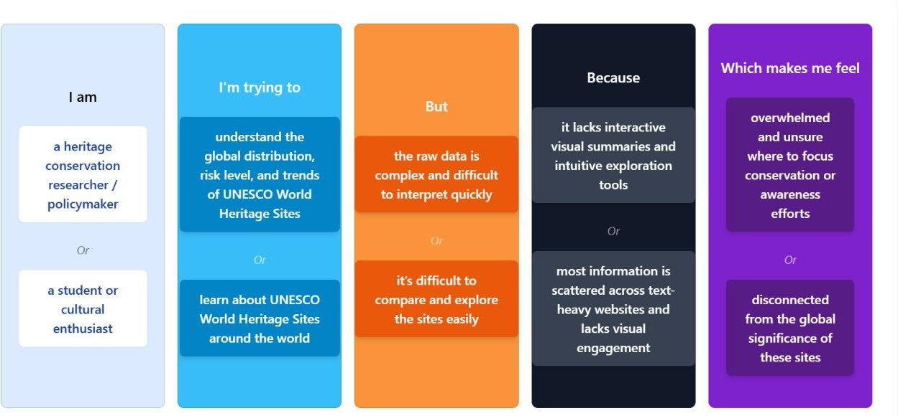

|  |  |  |  |  |  |
| --- | --- | --- | --- | --- | --- |
| Problem  Statement(PS) | I am (Customer) | I’m trying to | But | Because | Which makes  me feel |
| PS-1 | A heritage conservation researcher/policymaker | Understand the global distribution, risk level, and  trends of UNESCO World Heritage Sites | The raw data is complex and  difficult to interpret  quickly | It lacks interactive visual  summaries and  intuitive  exploration  tools | Overwhel Med and unsure Where to focus  conservation awareness efforts |
| PS-2 | A student or cultural enthusiast | Learn about UNESCO World Heritage Sites around the  world | It is  difficult to compare and  explore the sites easily | Most  information is scattered across text- heavy  websites and lacks visual  engagement | disconnected from the global  significance o these sites |